Teacher & Support Employee of the Year Celebration

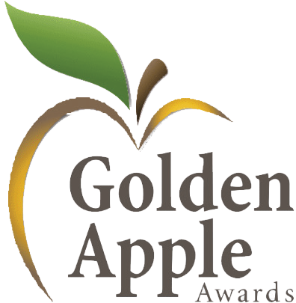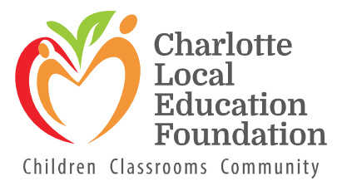

**Saturday, January 11, 2025 at 6pm**

at Sunseeker Resort

Sponsoring Company/Individual (How you wish to be recognized in print) Contact Name

Company Name Phone Full Address City, State ZIP Email Sponsorship Amount

Support from our community in the form of charitable sponsorships is one of the reasons we are able to recognize and honor teachers and support employees in a meaningful way. These outstanding educators and support employees definitely deserve a “Thank You” for their dedication and service during an extraordinary year!

Not only will your charitable sponsorship help honor our Charlotte County educators and support employees, but any net profits from this event support the Charlotte Local Education Foundation, supporting classroom projects that are not funded by normal tax revenue to help students succeed in their academic achievements.

Yes! Please add my name to the Golden Apple *Honor Roll* to show my support for Education in Charlotte County. Honor Roll members name and/or company logo will be included in social media activities and on Foundation website.

* Summa Cum Laude $15,000 *(includes 10 tickets)*
* Magna Cum Laude $10,000 *(includes 10 tickets)*
* Cum Laude $5,000 *(includes 8 tickets)*
* Valedictorian Sponsor $2,500 (*includes 8 tickets)*
* Salutatorian Sponsor $1,000 *(includes 6 tickets)*
* With Distinction Sponsor $500 *(includes 4 tickets)*
* Cheerleader Sponsor $250 *(includes 2 tickets)*
* Friends of Education $100

Please return this form with payment by January 13, 2023. Checks should be made out to Charlotte Local Education Foundation, or visit our website and click on DONATE NOW.

18150 Murdock Circle Port Charlotte, FL 33948

Phone: 941-255-7500 ext. 1798

[daniel.washington@yourcharlotteschools.net](mailto:daniel.washington@yourcharlotteschools.net)

charlotteschoolfoundation.org

**Charlotte Local Education Foundation Inc. is a private 501 (c)3 nonprofit organization. This organization is registered with the State of Florida.**

**CHARLOTTE LOCAL EDUCATION FOUNDATION IS A PRIVATE 501 (C)3 NONPROFIT ORGANIZATION. THIS ORGANIZATION IS REGISTERED WITH THE STATE OF FLORIDA- REGISTRATION #CH2190. A COPY OF THE OFFICIAL REGISTRATION AND FINANCIAL INFORMATION MAY BE OBTAINED FROM THE DIVISION OF CONSUMER SERVICES BY CALLING 800-435-7352 WITHIN THE STATE. OUTSIDE OF FLORIDA, CALL 850-488-2221. OR VISIT** [**WWW.800HELPFLA.COM**](http://WWW.800HELPFLA.COM/) **REGISTRATION DOES NOT IMPLY ENDORSEMENT, APPROVAL, OR RECOMMENDATION BY THE STATE. ALL DONATIONS TO CHARLOTTE LOCAL EDUCATION FOUNDATION, ARE TAX-DEDUCTIBLE TO THE EXTENT PERMITTED BY LAW.**